**Non-functional testing examples**

**1. Stability testing:** a CPU (central processing unit) test is a popular form of stability test. It checks processor stability and also monitors its performance while the processor's workload is increased.

2. **Usability testing**: The Gorenje company has conducted a survey among gas- stove users. According to the survey results, the users weren't satisfied with the absence of electric firing. The Gorenje company take the survey results into account and added electric firing into the next models.

3. **Efficiency** testing: A login page for testing- make a long list with user-names and passwords (that may be possible). Set them for a quick login, for an automated test. Populate the list with SQL with the insertion of different punctuations and irregular capitalization. Every test will work so fast that a tester can do a test with more data than the manually.

4. **Maintainability** testing: There is a broken CPU in a computer. We evaluate how easy it is to get a new CPU of the same model in order to repair the computer.

5. **Portability** testing: The Kharkovforum site was initially written to work on the Apache server. Then the site owners decided to port it to the NginX server.

6. **Baseline** testing: The OnTaxi application gives a good performance for at least 500 users at a particular time, so the baseline is 500 users. It means that a new application should work perfectly for a minimum of 500 users.

7. **Compliance/acceptance** testing: the emergency service has ordered blood glucose meters. When receiving the ordered equipment, two groups of people who were chosen among the staff were invited. The test group were patients with diabetes, while the other group were a control group. The glucose meters were tested on the test group to confirm their performance.

8. **Documentation** testing: A hospital has ordered an ECG device. When receiving, the documentation was checked to cover all the necessary information as to the use of the ECG device.

9. **Endurance** testing: When producing a CPU block, it is tested to maintain the maximum voltage as per its technical specification.

10. **Load** testing: When producing a CPU block, it is tested to maintain the minimum and maximum voltage as per its technical specification.

11. **Performance** testing: A test to check what frames per second can be expected from a gaming computer when playing GTA 5 at maximum visual settings.

12. **Compatibility** testing: A test to check if the Photoshop application runs on Windows, Mac and Unix platforms and also if it runs on the Intel and AMD CPUs.

13. **Security** testing: Engineers have tested a gas-control function of a gas-stove. If a fire has disappeared, but the gas system didn't stop the gas, it should be stopped automatically.

14. **Volume** testing: testing the zajcev.net site behavior when there are millions of users trying to download the song.

15. Stress testing: testing the behaviour of the Viber application when there is not enough memory available and users still continue sending you large photos.

16. Recovery testing: The Telegram application depends on the Internet connection. The Internet connection has been interrupted. The test evaluates the amount of time Telegram takes to see that the Internet connection has been reestablished and continue receiving income messages.

17. Localization testing: testing the Russian localized version of the WhatsApp application to check if all the text, icons and messages are written in correct Russian.

**Four levels of testing the OLX site**

1. Unit testing. We are testing the 'login' module of the OLX site. First we test if a user can access the site when entering the correct credentials. We were able to access the site. Then we test the case when the correct login is entered but an incorrect password is provided. The system doesn't allow to access the site.

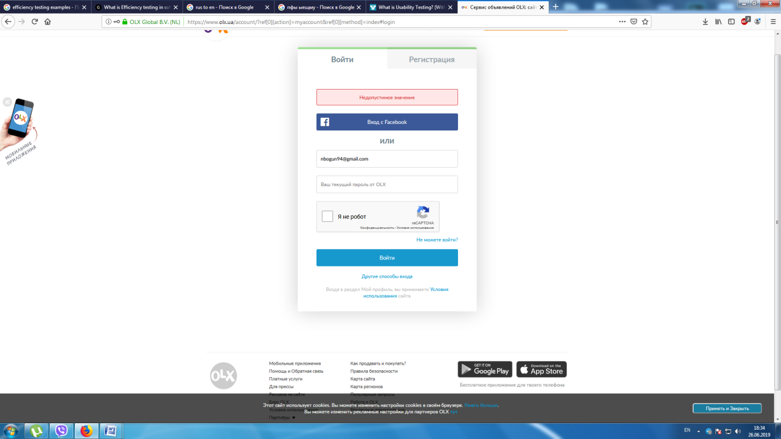

Then we provided the incorrect login and the correct password.

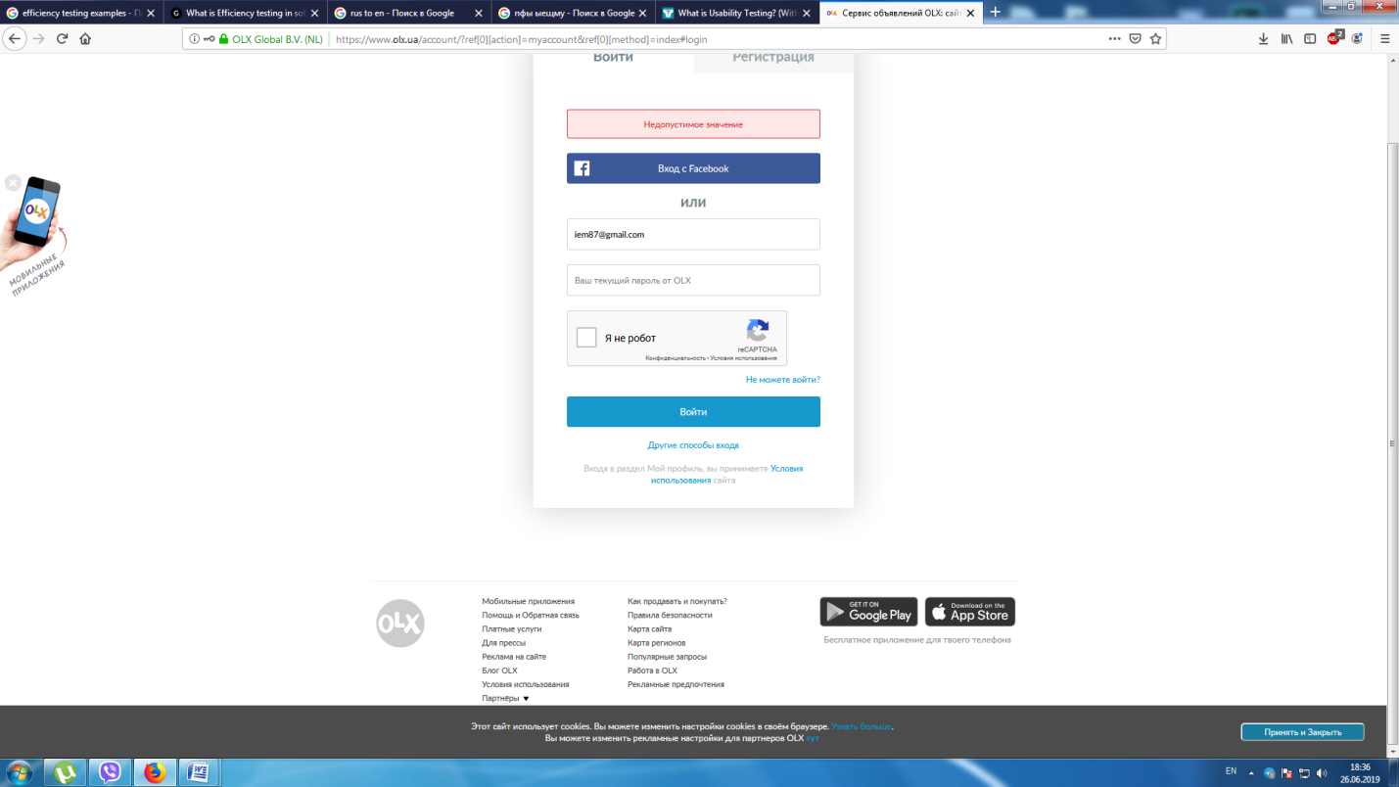

2. Integration testing: We are testing the integration of two units: registration and login. First we create a new user account.

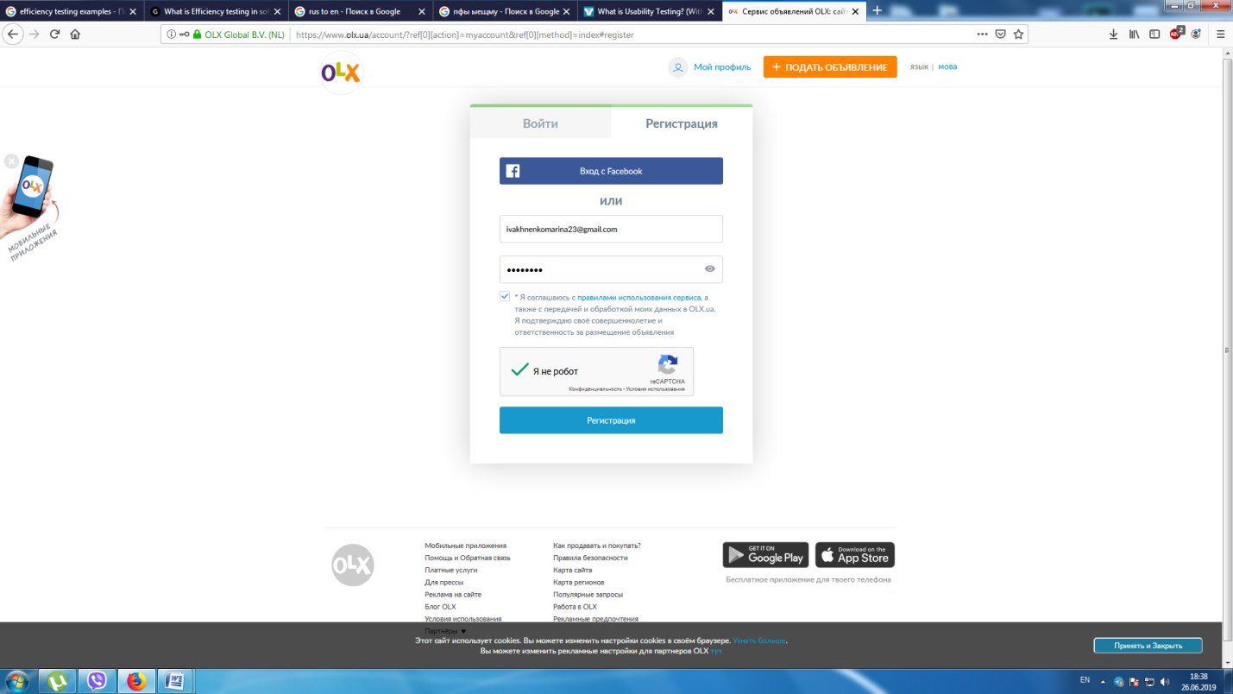

Then we check if it is possible to enter the new account by providing the respective credentials

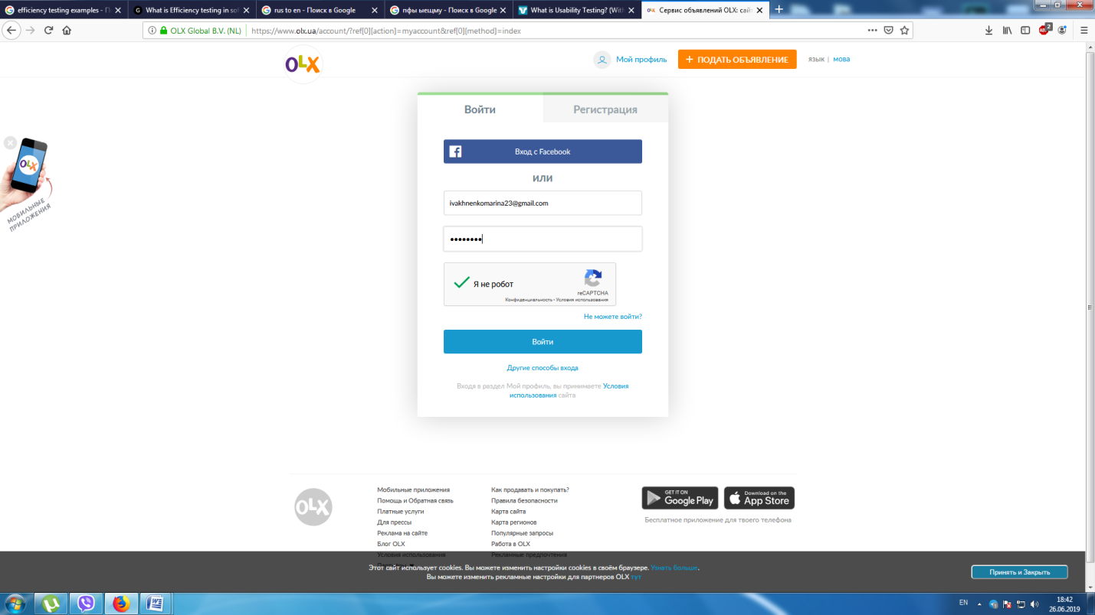

The site successfully takes us to the new account page.

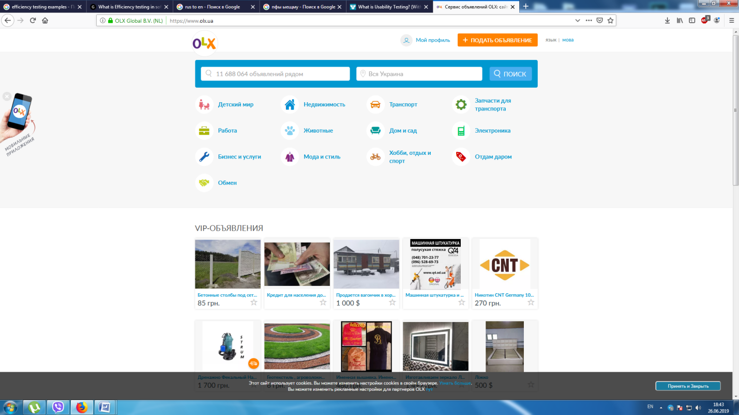

3. System testing: The development of the OLX site has been finished. We test it entirely on several browsers: Firefox and Chrome. The first test if on Firefox. We enter the correct user credentials to access the account. The site has successfully allowed us access to the account.





The second test is for the Chrome browser. We enter the correct user credentials to access the account. The site has successfully allowed us access to the account.

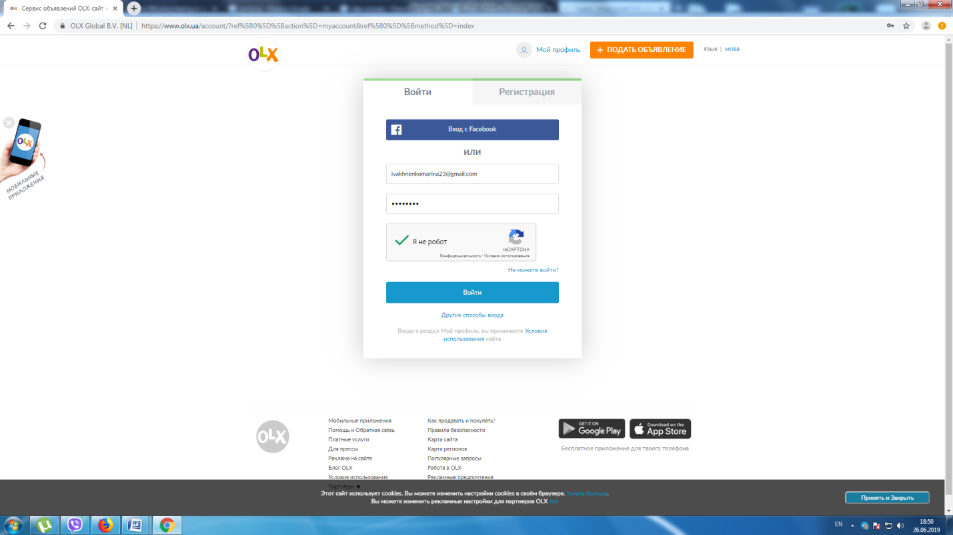

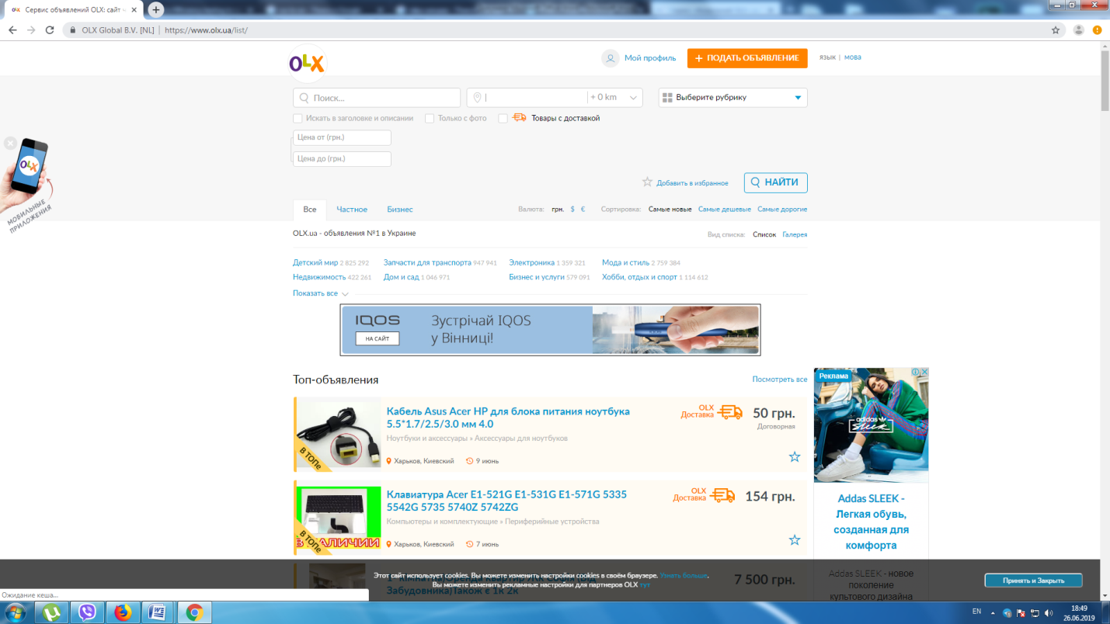

4. Acceptance testing: The owner of the OLX site when receiving the finished result from the web-development company has its staff test the site behavior and functionality.